AWS Website Deployment
- What We Are Doing
We will:
- Create a virtual server (EC2) on AWS
- Install a web server (Apache)
- Upload our website files
- Make the website publicly accessible
This is how real companies host websites on cloud servers.
STEP 1: AWS Account & Region Selection
What is AWS?
AWS (Amazon Web Services) is a cloud platform that provides servers, storage, databases, networking, and security on a pay-as-you-go model.
Create AWS Account
- Open browser → https://aws.amazon.com
- Click “Create an AWS Account” (top-right)
Enter Account Details
- Root Email: your email (e.g., lakshman@example.com)
- Password: strong password
- AWS Account Name: e.g., LakshmanAWS
- Click “Continue”
Account Type
- Choose Personal or Professional
- Enter full name, phone number, country, and address
- Click “Create Account and Continue”
Payment
- Enter credit/debit card (required for verification)
- Verify and continue
Identity Verification
- Enter phone number, receive OTP, verify
Support Plan
- Select Basic (Free) → Complete Sign Up ✅

STEP 2: Sign in to AWS Console
- Go to https://aws.amazon.com/console/
- Click Sign In to Console → Choose Root User
- Enter root email → Next
- Enter password → Sign In
Now you are inside AWS Console
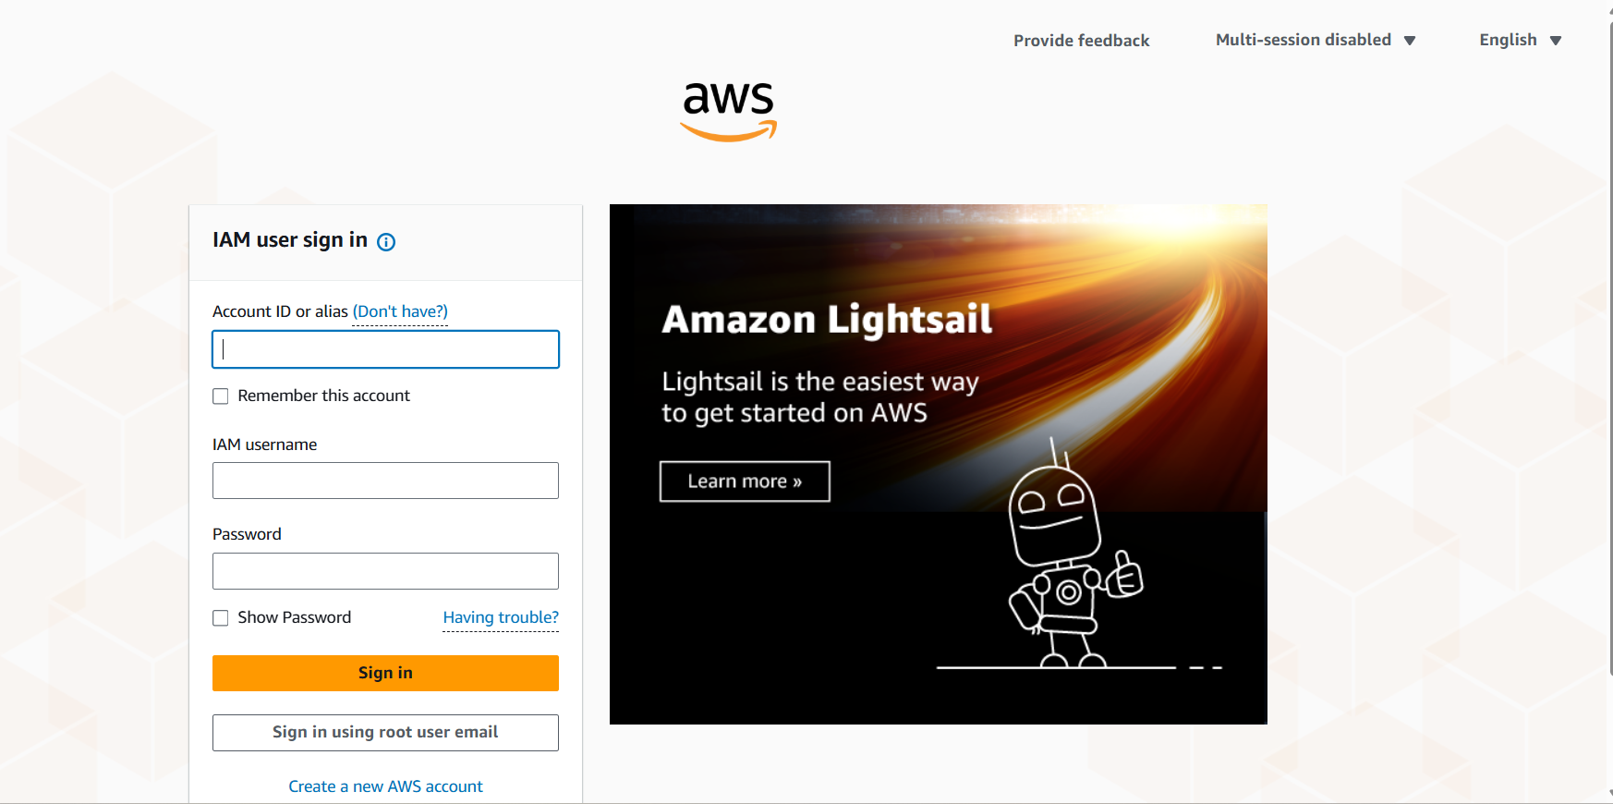
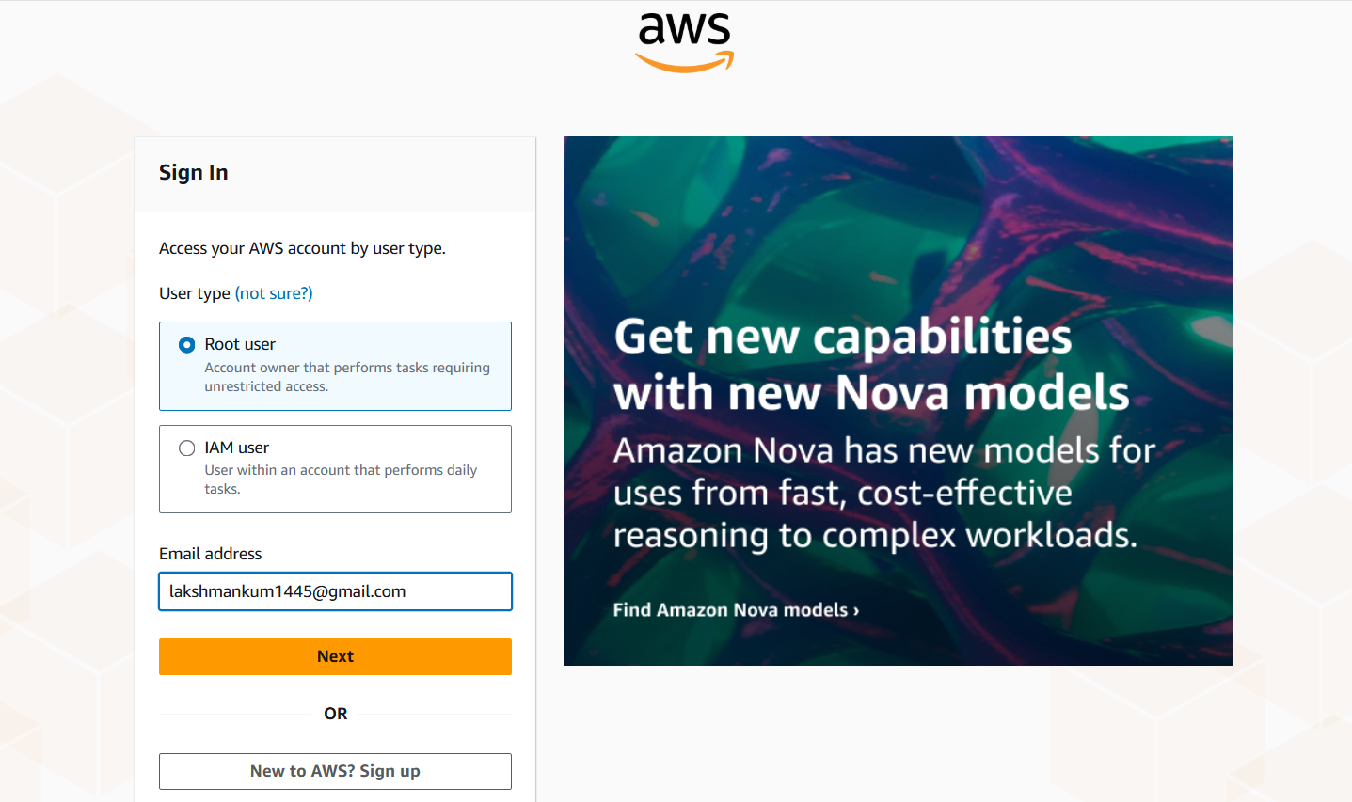
STEP 3: Launch EC2 Instance (Virtual Server)
- In AWS Console → Search EC2 → Click Launch Instance
Instance Configuration
- Name: my-website-server
- AMI: Amazon Linux 2 (Free Tier)
- Instance Type: t2.micro (Free Tier)
Key Pair
- Create new key pair → Name: website-key → Download .pem
Keep .pem safe, needed for SSH
Security Group (Firewall)
- Allow:
  - SSH (22) → My IP
  - HTTP (80) → Anywhere
  - HTTPS (443) → Anywhere
Click Launch Instance ✅
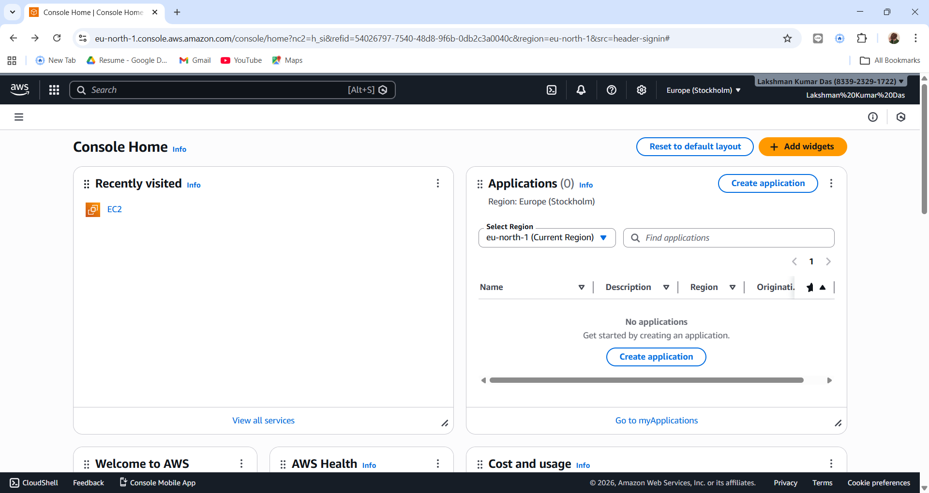
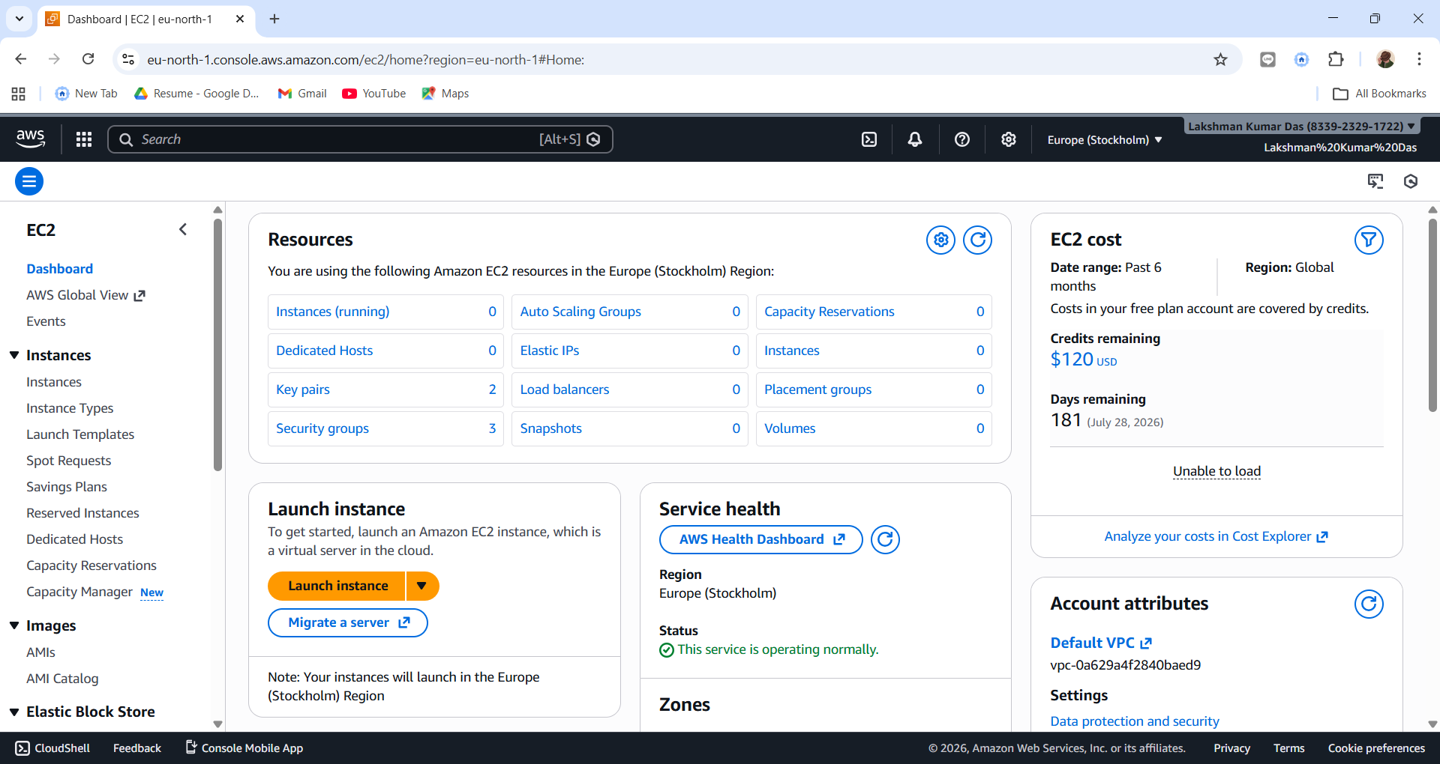
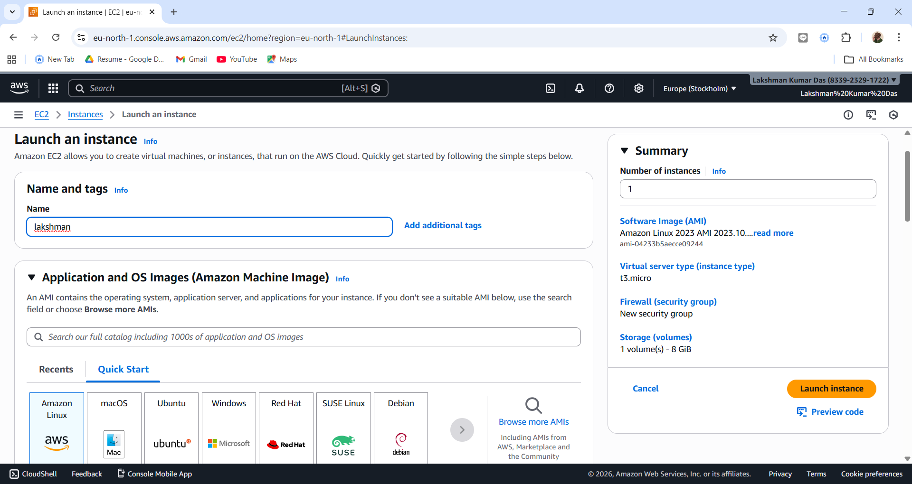
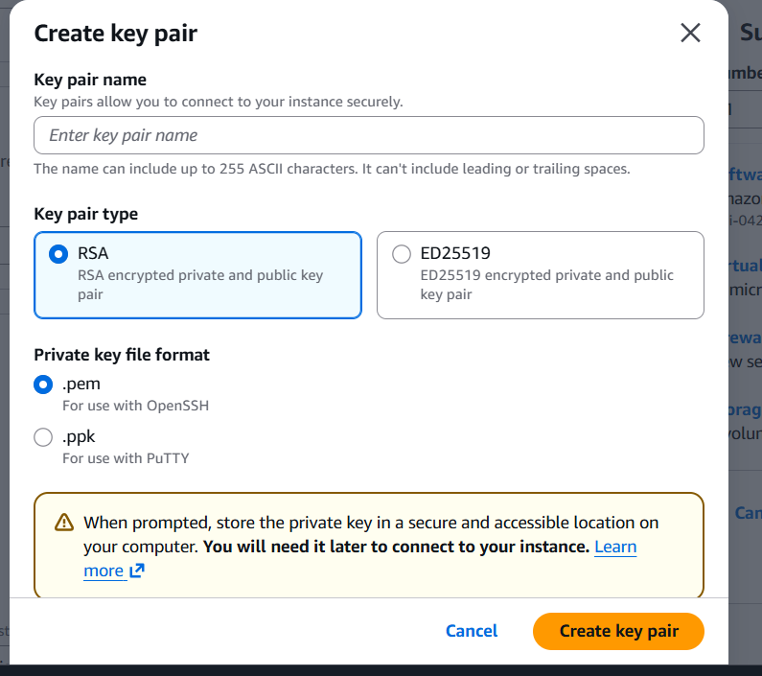
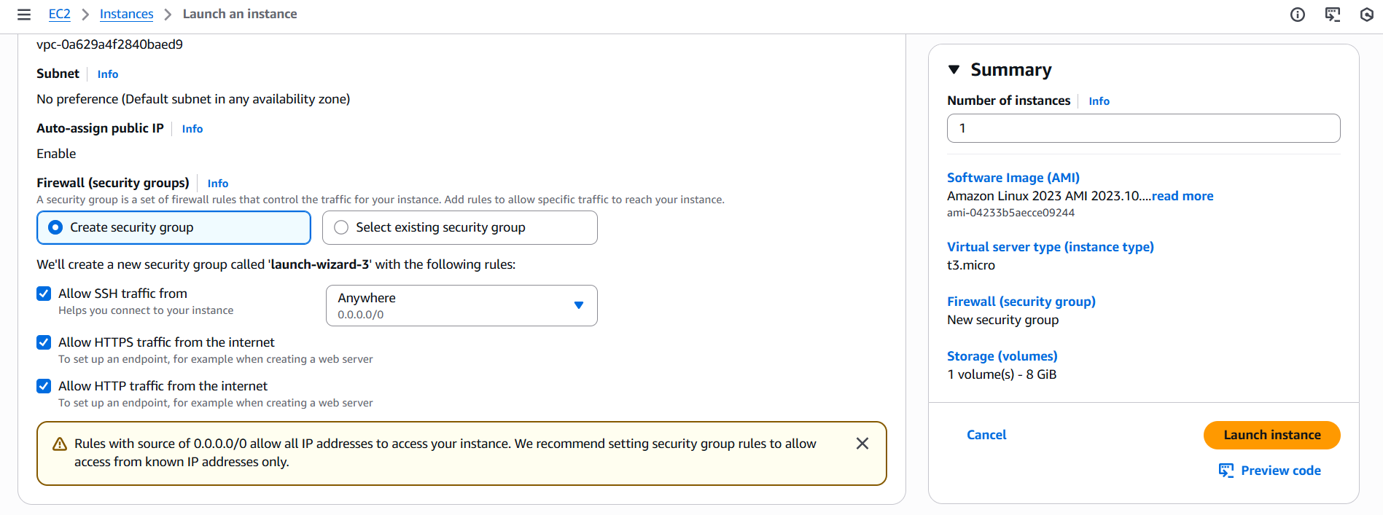
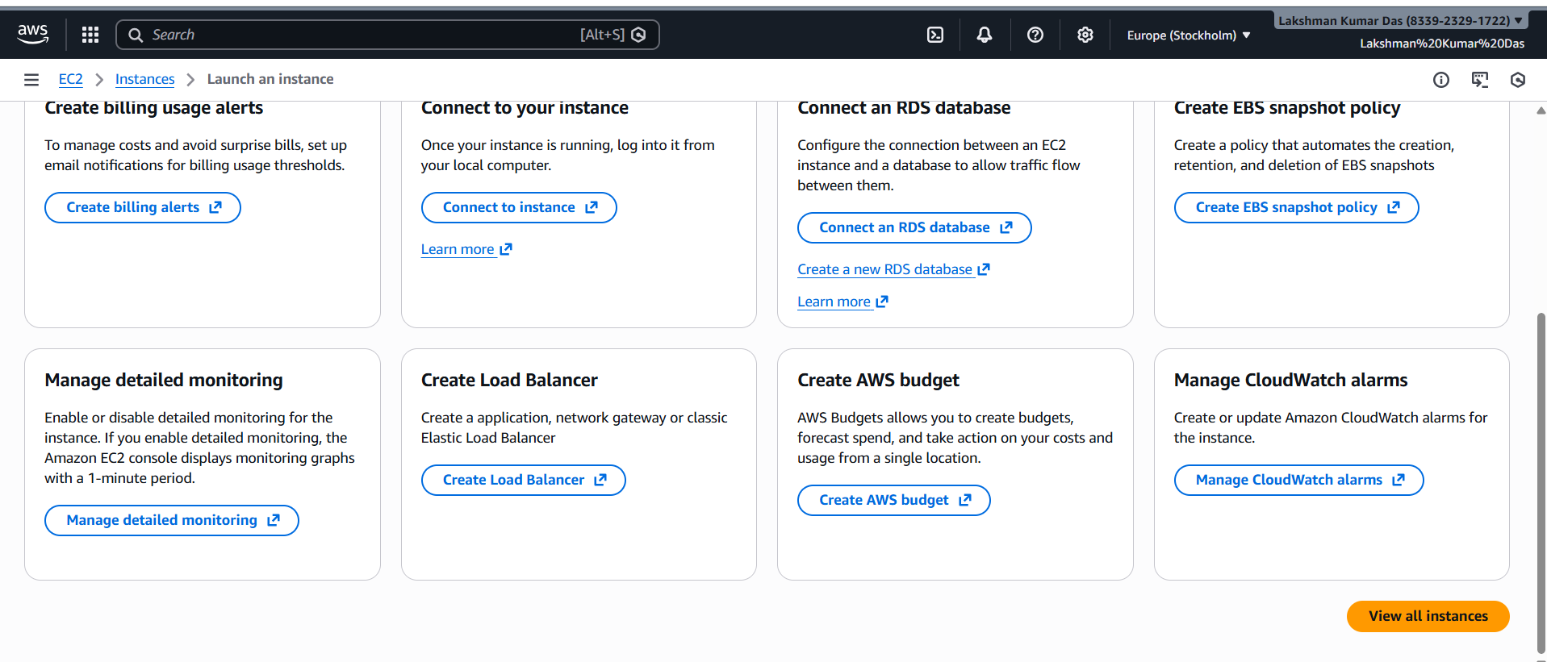
Step 4.
Right-click on your instance → You will see a menu with options like:
And then select connect
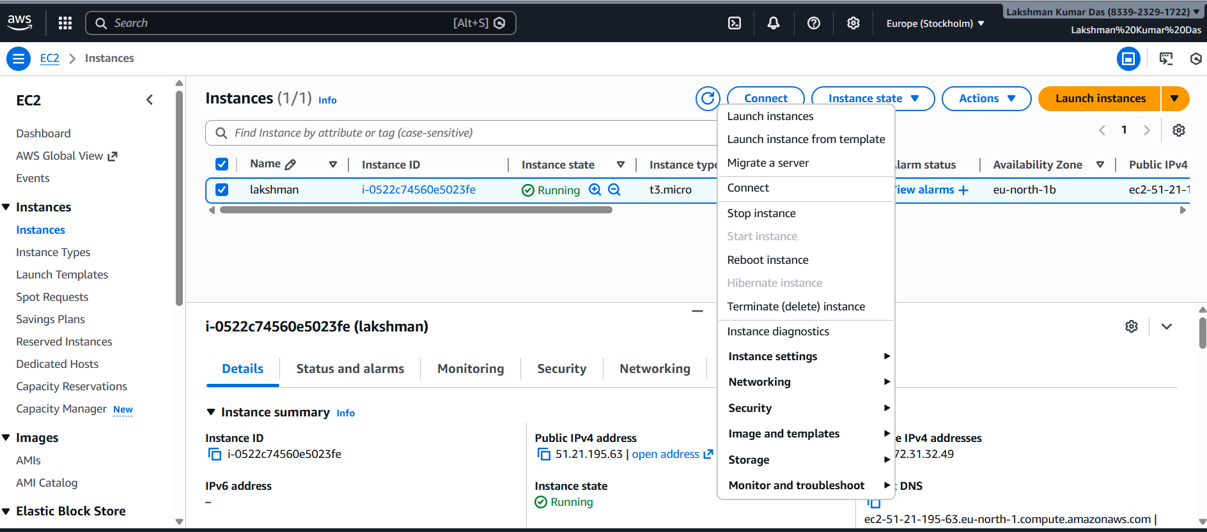
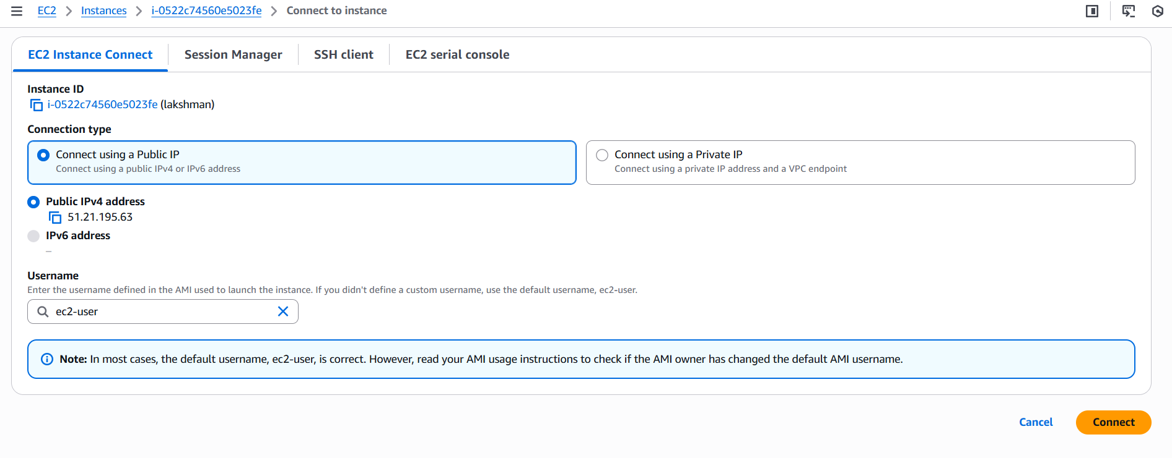

STEP 5: Install Apache Web Server
  - sudo yum update -y
  - sudo yum install httpd -y
  - sudo systemctl start httpd
  - sudo systemctl enable httpd
Step 6: Deploy Your Website
- Install Git:
sudo yum install -y git
- Clone your GitHub repository:
git clone https://github.com/thebugbounter/preet-watches.git /var/www/html/
- Adjust ownership and permissions:
- sudo chown -R apache:apache /var/www/html
sudo chmod -R 755 /var/www/html
Step 8: Access Your Web Server
Open your web browser: Go to the public DNS address of your instance. You should see the content of your website deployed from the GitHub repository.
